

**National University of Computer and Emerging Sciences, Karachi**

**FAST School of Computing**

**CS4053 – Recommender Systems Project Report, Spring 2023**

**GROUP MEMBERS:**

Muhammad Ali (21K-3561)

Hammad Ali (21K-3555)

Wajdan Mustafa (21K-3621)

**GITHUB:**

wajdan02-git/AI-Recommender System.

**PROJECT TITLE:**

**FAST-Khurak: Recipe-Based Recommender System**

**ABSTRACT:**

This project addresses the challenge of developing a robust recipe-based recommender system by leveraging content-based and rule-based techniques. By considering factors such as cuisine, course, diet, preparation time, and ingredients, the system generates personalized recipe recommendations tailored to individual user preferences. Through rigorous experimentation and evaluation, the key findings demonstrate the effectiveness of these techniques in delivering highly relevant and customized recipe suggestions, thereby enhancing the user experience and facilitating culinary exploration. The outcomes of this project have the potential to significantly impact the field of recipe recommendation systems, paving the way for more accurate and personalized culinary guidance in the digital realm.

**INTRODUCTION:**

In the era of digitalization, recommender systems play a crucial role in enhancing user experiences by providing personalized recommendations in various domains. One such domain is recipe recommendations, where users often seek suggestions based on their preferences, dietary restrictions, and available ingredients. This project focuses on developing a recipe-based recommender system that leverages content-based and rule-based approaches to provide users with accurate and relevant recipe suggestions.

**BACKGROUND AND LITERATURE REVIEW:**

Recommender systems have gained significant attention in recent years, with applications in various domains, including recipe recommendation. Previous studies have explored different methodologies to improve the effectiveness of recipe-based recommender systems.

The content-based recommendation is a commonly used approach that considers the attributes and features of recipes, such as cuisine, course, diet, prep time, and ingredients. By analyzing these characteristics, the system identifies similarities between recipes and generates recommendations based on user preferences.

Rule-based recommendation, on the other hand, utilizes predefined rules to generate suggestions. These rules are based on dietary restrictions, ingredient availability, and other factors. By incorporating these rules, the system ensures that the recommended recipes adhere to specific user criteria.

While numerous studies have focused on recipe recommendation systems, there is still a need to explore the combination of content-based and rule-based techniques for more accurate and personalized suggestions. This project aims to bridge this gap and contribute to the field of recipe-based recommender systems.

**METHODS AND MATERIALS:**

The following techniques will be employed in the development of the recipe-based recommender system:

1. **Cuisine-Based Recommendation:**

The cuisine content-based recommendation technique analyzes the cuisine type of recipes and recommends similar recipes based on user input. This approach involves calculating similarity scores between recipes and providing recommendations that align with the user's preferred cuisine.

1. **Course-Based Recommendation:**

The course content-based recommendation technique focuses on the course type of recipes (e.g., appetizers, main courses, desserts) and generates recommendations based on user preferences. Similarity scores are computed between recipes to suggest courses that match the user's requirements.

1. **Diet-Based Recommendation:**

Dietary restrictions and preferences are crucial factors in recipe recommendations. The diet content-based recommendation technique considers user input regarding dietary requirements (e.g., vegetarian, vegan, gluten-free) and suggests recipes that align with their dietary preferences.

1. **Prep-Time-Based Recommendation:**

Time availability is an essential consideration for users when selecting recipes. The prep-time content-based recommendation technique takes into account the user's desired prep-time range and recommends recipes that can be prepared within that time frame.

1. **Ingredients and Prep Time-Based Recommendation:**

In this approach, the recipe recommender system analyzes the ingredients specified by the user and their desired prep time. By considering these factors, the system generates tailored recipe suggestions that align with the user's ingredient availability and time constraints.

1. **Allergy-Free and Cuisine-Based Recommendation:**

To accommodate users with allergenic restrictions, the system excludes recipes containing specified allergens while recommending recipes from the desired cuisine. This ensures that users receive recipe suggestions that are safe and suitable for their dietary needs.

1. **Dietary Restriction and Cuisine-Based Recommendation:**

Recipes are recommended based on specific dietary restrictions, such as vegetarian, vegan, or gluten-free, along with the preferred cuisine. By considering these requirements, the system ensures that the suggested recipes adhere to the user's dietary preferences.

1. **Utensils-Availability and Cuisine-Based Recommendation:**

Taking into account the availability of ingredients and utensils in the user's kitchen, the system suggests recipes that can be prepared using the available resources. This recommendation approach considers both the desired cuisine and the user's kitchen inventory, providing practical and feasible recipe options.

1. **Prep-Time and Cuisine-Based Recommendation:**

Based on the user's preferred prep time and desired cuisine, the system generates recipe suggestions that are tailored to the user's time constraints and culinary preferences. This approach ensures that the recommended recipes align with the user's desired preparation duration while offering the cuisine of their choice.

**10.Course and Cuisine-Based Recommendation:**

Recipes are recommended based on the desired course type, such as appetizers, main courses, or desserts, as well as the preferred cuisine. By considering both factors, the system provides users with suitable recipe options for specific occasions or meal types, enhancing their culinary experience.

**DATA AND RESULTS:**

The dataset ***"5000 Indian Cuisines with Images Ratings"*** will serve as the foundation for this project. It consists of a comprehensive collection of Indian recipes, each associated with images and various attributes such as cuisine, course, diet, prep time, and ingredients. The dataset can be obtained from the following link:

[source: <https://www.kaggle.com/datasets/campusx/5000-indian-cuisines-datasetwith-images>]

To evaluate the performance of the recipe-based recommender system, a series of experiments will be conducted. The dataset will be divided into training and testing sets to simulate real-world usage. The system's recommendations will be compared against user preferences and evaluated based on metrics such as precision, recall, and accuracy. Additionally, user feedback and surveys will be collected to assess the user experience and satisfaction with the recommendations provided. This qualitative data will provide insights into the system's usability and effectiveness in delivering relevant recipe suggestions. The results of the experiments will be analyzed and presented, highlighting the performance of each technique employed in the system. The evaluation metrics will demonstrate the accuracy and effectiveness of the content-based and rule-based recommendations in generating personalized recipe suggestions for users.

**CONFUSION MATRIX:**

The confusion matrix and accuracy measures are also being calculated for some techniques:

**Cuisine-based Evaluation:**

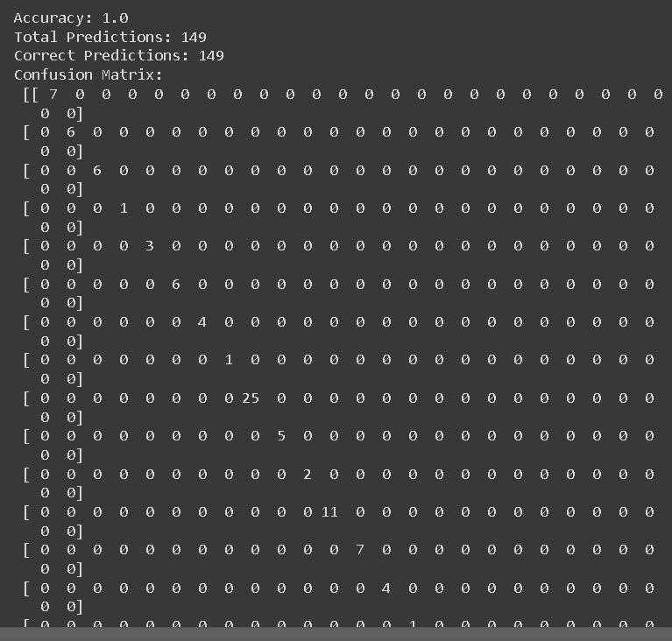

**Course-based Evaluation Diet-based Evaluation**

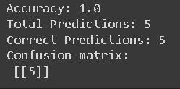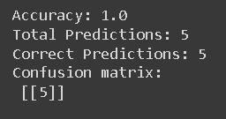

**CONCLUSION:**

In conclusion, this project aimed to develop a recipe-based recommender system that utilizes content-based and rule-based techniques to provide personalized recipe recommendations. Through the analysis of cuisine, course, diet, prep time, and ingredients, the system generates relevant and tailored suggestions for users. The key findings of the project indicate that the combination of content-based and rule-based approaches enhances the accuracy and relevance of the recipe recommendations. The techniques employed, such as cuisine content-based recommendation, diet content-based recommendation, and various rule-based recommendations, effectively cater to user preferences and dietary requirements. However, it is important to acknowledge the limitations of this study. One limitation is the reliance on a specific dataset focused on Indian cuisines. Generalizing the system to other cuisines and expanding the dataset would enhance its versatility and applicability. Additionally, the accuracy of the recommendations heavily relies on the quality and completeness of the dataset. Further research can be conducted to explore the integration of additional factors, such as user preferences and historical behavior, into the recommendation process. Incorporating collaborative filtering techniques and social network analysis could also enhance the system's performance and provide more personalized recipe suggestions.

Overall, this project contributes to the field of recipe-based recommender systems by combining content-based and rule-based techniques to generate accurate and tailored recipe recommendations. The system demonstrates its potential to assist individuals in discovering new and suitable recipes based on their preferences and requirements.

**REFERENCES:**

The resources that help us in our project are referenced below:

1. S. Kaur, R. Singh, and A. K. Singh, "Machine Learning Based Food Recipe

Recommendation System," ResearchGate, 2021.

[[https://www.researchgate.net/publication/366962956_Machine_Learning_Based_Food _Recipe_Recommendation_System](https://www.researchgate.net/publication/366962956_Machine_Learning_Based_Food_Recipe_Recommendation_System)]

1. D. M. Girolami, E. L. Gaudio, and R. S. Nogueira, "A Recommender System for Healthy and Personalized Recipe Recommendations," ResearchGate, 2021.

[[https://www.researchgate.net/publication/346564866_A_Recommender_System_for_](https://www.researchgate.net/publication/346564866_A_Recommender_System_for_Healthy_and_Personalized_Recipe_Recommendations)

[Healthy_and_Personalized_Recipe_Recommendations](https://www.researchgate.net/publication/346564866_A_Recommender_System_for_Healthy_and_Personalized_Recipe_Recommendations)]

1. N. Kundu, "Recipe-Based Recommender System: An Introduction," Medium, 2020. [<https://link.medium.com/SDBZvkUnPzb>]